**DAILY ONLINE ACTIVITIES SUMMARY**

|  |  |  |  |  |  |  |  |  |
| --- | --- | --- | --- | --- | --- | --- | --- | --- |
| **Date:** | **23/5/2020** | | | | | **Name:** | **Banish M G** | |
| **Sem & Sec** | **8th Sem** | | | | | **USN:** | **4AL16CS020** | |
| **Online Test Summary** | | | | | | | | |
| **Subject** | | **---------** | | | | | | |
| **Max. Marks** | | **----** | | **Score** | | | **-----** | |
| **Certification Course Summary** | | | | | | | | |
| **Course** | **DataCamp : Supervised learning with Scikit learning** | | | | | | | |
| **Certificate Provider** | | | **Datacamp** | | **Duration** | | | **4 hrs** |
| **Coding Challenges** | | | | | | | | |
| **Problem Statement:**  1: Write a C Program to Display first N Triangular Numbers (Where N is read from the Keyboard) | | | | | | | | |
| **Status:COMPLETED** | | | | | | | | |
| **Uploaded the report in Github** | | | | | **yes** | | | |
| **If yes Repository name** | | | | | B**anish_MG** | | | |
| **Uploaded the report in slack** | | | | | **yes** | | | |

Online Test Details: (Attach the snapshot and briefly write the report for the same)

Certification Course Details: (Attach the snapshot and briefly write the report for the same)

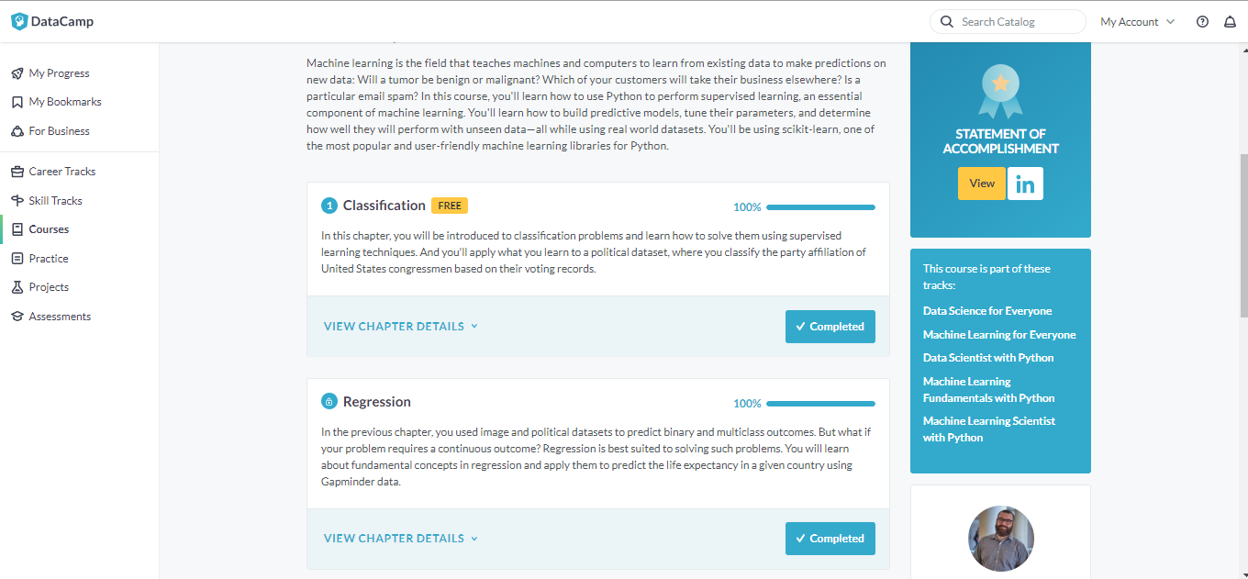

Coding Challenges Details: (Attach the snapshot and briefly write the report for the same)

#include <stdio.h>

void triangular_series(int n)

{

for (int i = 1; i <= n; i++)

printf(" %d ", i*(i+1)/2);

}

int main()

{

int n ;

printf("Enter value for n");

scanf("%d",&n);

triangular_series(n);

return 0;